CAA/PL/P/01

Civil Aviation Authority of Sri Lanka
Issuance of Student Pilot Licence

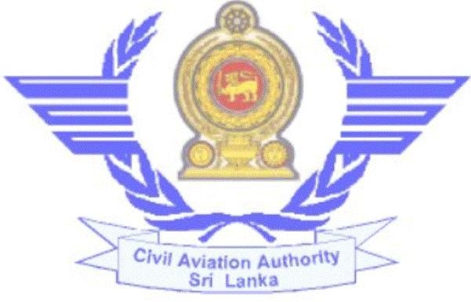

Published by the Civil Aviation Authority of Sri Lanka

SPL Issuance

Requirements:-
  - Age not less than 16 years.
  - Competency in the English language
  - Medical fitness (Class I or Class II)
  - Security Clearance / Police Report
  - Letter of enrollment from Approved Flying Training Organisation

Procedure:-
- Enroll with an Approved Flying Training Organisation
- Register with the computerized Licensing System through www.caa.lk
- Create the user profile and add the SPL issuance application form.
- If you need any assistance to create the profile or add new application, press the “Help” button.
SPL Issuance

Documents Required:-
- Originals and Copies of Educational Qualifications, National Identity Card/ Passport & Birth Certificate
- Approved Flying Training Organisation Enrolment Certificate (for trainees)
- 2 stamp size (2cm X 2cm) photographs

Relevant fees:- (Without tax)
  - Medical Examination fee (As per the class of medical)
  - Application Evaluation fee – Rs. 6000.00/=
  - SPL issuance fee – Rs. 3000.00/=

In addition to above, relevant tax to CAASL and laboratory evaluation charges shall be paid to the hospital.

- Visit the Personnel Licensing Counter with the original documents and make the relevant payment to commence the

process of evaluation of the application.
- The requirements for issuance of Student Pilot Licences have been published in Implementing Standard 72 which you can download from the website.
- Submit Personnel Particulars form No. CAA/PL/M/12 to obtain Security Clearance
- Submit application for Medical Examination under a CAA Medical Examiner.
- Check the status of the application through your profile in the Licensing System.
Civil Aviation Authority of Sri Lanka, No 152/1, Minuwangoda Road, Katunayake.

Telephone : 011-2358942
Fax : 011-2257297
E-Mail : dtopl@caa.lk
scaiplfc@caa.lk

Web : www.caa.lk

30th September 2023 Revision 03 CAASL 30th September 2023 Revision 03 CAASL

