CAA/PL/P/05

Civil Aviation Authority of Sri Lanka

ATPL Direct Issuance

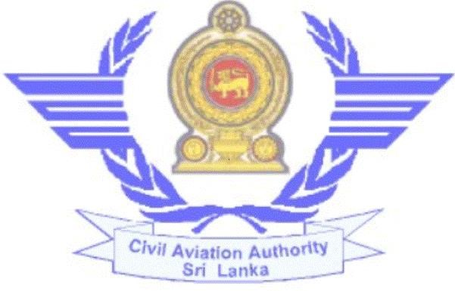

Published by the Civil Aviation Authority of Sri Lanka

Direct Issuance of ATPL Direct Issuance of ATPL
- Requirements:- c) Flying experience: - Refer IS 72, Subpart F, Appendix 3
1. Age not less than 21 years.
  - Medical fitness (Class I). d) Procedure:-
  - Security Clearance. 1. Register with the computerized Licensing System through
  - Successful completion of ground training and flying training www.caa.lk
in an approved flying training organization (ATO). 2. Create the user profile and add the Airline Transport Pilot
  - ATPL Theory Examinations. ((Ref. IS 72 for more details) Licence Issuance application form.
  - English Language Proficiency. (Level 4 or higher) 3. If you need any assistance to create the profile or add new
  - Flying experience as “C” below. application, press the “Help” button.
  - ATO / Airline recommendation for theory 4. Visit the Personnel Licensing Section with the original
examinations and skill test. documents and make the relevant payment to commence the
  - Successful completion of skill test. process of evaluation of the application.
  - All other requirements stipulated in IS 072 which 5. Submit Personnel Particulars form to obtain Security Clearance.
you can download from the website www.caa.lk 6. Submit application for Medical Examination under a CAA
Medical Examiner to obtain Class I Medical Certificate.
- Supportive documents to be submitted: - 7. Appear for theory examinations, ELPC examinations at CAASL.
1. Duly completed Personal Particulars form 8. Obtain SPL. (If you don’t have valid licence & see the procedure
2. Duly completed Application for Medical Examination for obtaining of SPL)
3. Duly completed Application for Theory Examinations with 9. Complete recent flying & hand over instructor report or log
recommendation letter from ATO. book copies. If you don’t have recent flying experience.
- Duly completed evaluation form for English Language 10. If all other requirements are completed, collect the letter
Proficiency check (CAA/PL/E/08) for flight test and submit Flight Test Examiner report &
- Log Book certified by ATO / Airline together with ATC observer’s report.
copies indicating total and recent flying experience 11. Check the status of the application through your profile in
6. Copy of NIC/Passport / Birth certificate. the Licensing System.
7. Detailed breakdown of flying experience (“X” country,
Instrument Instructional and Night flying)
8. ATO / Airline recommendation letter/ instructor report
or log book copies for skill test
9. Skill test report and observer’s report. 30th September 2023 Revision 01 CAASL

30th September 2023 Revision 01 CAASL

e) Relevant fees:- (Without tax)

1. Application Evaluation fee – Rs. 9600.00/=
2. ATPL issuance fee – Rs. 4800.00/=
- Medical fee – (Contact Medical Unit)
- ATPL Examination fee (per subject) Rs. 7200.00/=
- English Language Proficiency check fee Rs. 3600.00/=
7. Flight Examiner Fee- Rs. 26400.00/=
In addition to the above, laboratory evaluation charges shall be paid to the hospital.

Civil Aviation Authority of Sri Lanka,
No.152/1, Minuwangoda Road
Katunayake  Telephone  Fax  E-Mail | :  :  : | 011-2358942, 011-2358946  011-2257297  dtopl@caa.lk
scaiplfc@caa.lk
Web : www.caa.lk

30th September 2023 Revision 01 CAASL

