CAA/PL/P/03

Civil Aviation Authority of Sri Lanka
Direct Issuance of CPL
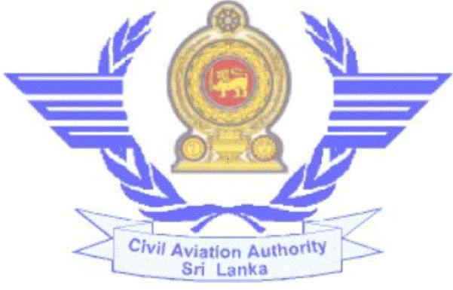

Published by the Civil Aviation Authority of Sri Lanka
Direct Issuance of CPL

- Requirements:-

  - Age not less than 18 years.
  - Medical fitness (Class I).
  - Security Clearance

  - Successful completion of ground training and flying training in approved Flying Training Organisation.

  - CPL Theory Examinations or ATPL Theory examinations. (Ref. IS 072 for more details)

  - Flying experience as “C” below.
  - English Language Proficiency. (Level 4 or higher)

  - Approved Training Organisation’s recommendation for theory examinations and skill test.

  - Successful completion of skill test

  - All other requirements stipulated in Subpart D & Appendix 3 of IS 072 which you can download from the website www.caa.lk

- Supportive documents to be submitted:-

  - Duly completed Personnel Particulars form

  - Duly completed Application for Theory Examinations with a recommendation letter from an approved flying training Organisation.

  - Duly completed evaluation form for English Language Proficiency check (CAA/PL/E/08)

  - Log Book certified by an approved Flying Training Organisation together with copies indicating total and recent flying experience.

  - Copy of NIC / Birth certificate.

30th September 2023 Revision 03 CAASL

Direct Issuance of CPL

  - Course completion certificate from approved Flying Training Organisation
  - Detailed breakdown of flying experience

  - Flying school recommendation letter/ instructor report or log book copies for skill test

  - Skill test report and ATC observer’s report.

- Flying experience: - Refer Sub Part D of IS 072 & Appendix 3

- Procedure:-

  - Join an approved Flying School & follow approved training program.

  - Once the course is completed submit course completion certificate to sit for knowledge examination.

  - Register with the computerized Licensing System through www.caa.lk

  - Create the user profile and add the Commercial Pilot Licence Issuance application form.

  - If you need any assistance to create the profile or add new application, press the “Help” button.

  - Visit the Personnel Licensing Section with the original documents and make the relevant payment to commence the process of evaluation of the application.
  - Submit Personnel Particulars form to obtain Security Clearance

  - Submit application for Medical Examination under a CAA Medical Examiner to obtain Class I Medical Certificate.
  - Appear for theory examinations, ELPC examinations at
CAASL.
  - Obtain SPL. If you don’t have valid Licence & see the procedure for obtaining of SPL.

30th September 2023 Revision 03 CAASL
Direct Issuance of CPL

  - Complete recent flying & hand over instructor report or log book copies. If you don’t have recent flying experience.
  - If all other requirements are completed collect letter for flight test and submit Flight Test Examiner report & ATC observer’s report.
  - Check the status of the application through your profile in the Licensing System.

- Relevant fees:- (Without tax)

1. | Application Evaluation fee – | Rs. 8400.00/=
2. | CPL issuance fee – | Rs. 4800.00/=
3. | Class 1 Medical Examination fee – | Contact Medical Unit
4. | CPL Examination fee(per subject) | Rs. 2400.00/=
5. | English Language Proficiency check fee – | Rs. 3600.00./=
6. | ATPL Examination fee (per subject)- | Rs. 7200.00/=
7. | Flight Examiners Fee (CPL) - | Rs.12000.00/=

In addition to above, laboratory evaluation charges shall be paid to the hospital.

Civil Aviation Authority of Sri Lanka,
No.152/1, Minuwangoda Rd, Katunayake

Telephone : 011-2358942
Fax : 011-2257297
E-Mail : dtopl@caa.lk
scaiplfc@caa.lk
Web : www.caa.lk

30th September 2023 Revision 03 CAASL

