CAA/PL/P/02

Civil Aviation Authority of Sri Lanka
Issuance of Private Pilot Licence
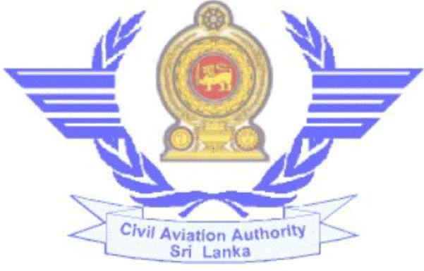

Issuance of PPL

- Requirements:-

  - Age not less than 17 years.
  - Medical fitness (Class I / II ).
  - Letter from an approved Flying Training Organisation
  - Security Clearance.
  - PPL Theory examination result sheet issued by CAASL

  - Enroll with an Approved Flying Training Organisation and undergo flying training successful completion of ground school and flying experience

  - Flying experience as “C” below.
  - English Language Proficiency. (Level 4 or higher)
  - An approved Flying Training Organisation recommendation for Examinations / skill test

- Supportive documents to be submitted:-

  - Duly completed Application for Examination of PPL (CAA/PL/E/01) from an approved Flying Training Organisation

  - Duly completed evaluation form for English Language Proficiency check (CAA/PL/E/08)

  - Letter from an Approved Flying Training Organisation

- Flying experience:-
For Private Pilot Licence.

- Total 40 hrs or 35 hrs if completed during a course of approved training
- 10 hrs of Solo flight time appropriate to the class rating sought
- 05 hrs Solo Cross country flight time with at least one cross flight totaling not less than 270km (150 NM) with two full stop landings at two different aerodromes.
- Instrument 05 hrs

30th September 2023 Revision 03 CAASL

Issuance of PPL

- Procedure:-

  - Register with the computerized Licensing System through www.caa.lk

  - Create the user profile and add the PPL issuance application form.

  - If you need any assistance to create the profile or add new application, press the “Help” button.

  - Visit the Personnel Licensing Section Counter with the original documents and make the relevant payment to commence the process of evaluation of the application.

  - The requirements for issuance of Private Pilot Licences have been published in Implementing Standards 072 which you can download from the website.

  - Submit Personnel Particulars form No. CAA/PL/M/12 to obtain Security Clearance

  - Submit online application for Medical Examination under a CAA Medical Examiner.

  - Appear for following examinations at CAASL.
    - PPL Technical Examination.
    - English Language Proficiency check
    - Flying test with appropriate type of Aircraft.

- Obtain SPL. If you don’t have valid SPL & see the procedure for obtaining of SPL.

- Finally collect letter for flight test and complete it, Submit
Examiner report & ATC observer’s report.

- Check the status of the application through your profile in the Licensing System

30th September 2023 Revision 03 CAASL

Issuance of PPL

e) Relevant fees:- (Without Tax)

1. | Application Evaluation fee – | Rs. 7200.00/=
2. | PPL issuance fee – | Rs. 3600.00/=
3. | Medical Examination fee – | (As per the class of medical)
4. | PPL examination fee (one subject) – | Rs. 1200.00/=
5. | English Language Proficiency check fee – | Rs. 3600.00/=
6. | Flight Examiners Fee (PPL) - | Rs. 8400.00/=

In addition to above, laboratory evaluation charges shall be paid to the
hospital.

Civil Aviation Authority of Sri Lanka,
No 152/1, Minuwangoda Road,
Katunayake.

Telephone : 011-2358942
Fax : 011-2257297
E-Mail : dtopl@caa.lk
scaiplfc@caa.lk
Web : www.caa.lk

Approved Training Organizations in SriLanka.

Kindly visit Details on Approved Training Organizations

30th September 2023 Revision 03 CAASL

